How to Read/Write SPIFlash with FlashROM and HydraBus

Example SPIFlash WINBOND W25Q16DV / HydraBus SPI2 connection
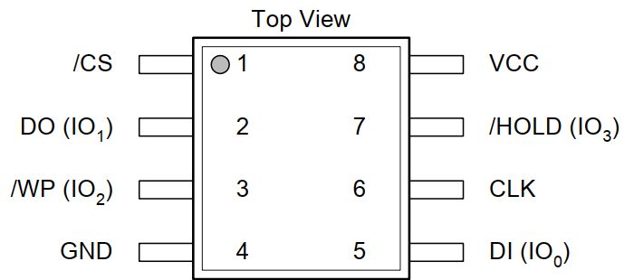
W25Q16DV /CS Pin1 <=> HydraBus SPI2 CS: PC1
W25Q16DV DO(IO1) Pin2 <=> HydraBus SPI2 MISO: PC2
W25Q16DV /WP(IO2) Pin3 <=> HydraBus 3V3 (disable write protect)
W25Q16DV GND Pin4 <=> HydraBus GND
W25Q16DV DI(IO0) Pin5 <=> HydraBus SPI2 MOSI: PC3
W25Q16DV CLK Pin6 <=> HydraBus SPI2 SCK: PB10
W25Q16DV /HOLD (IO3) Pin7 <=> HydraBus 3V3 (disable hold)
W25Q16DV VCC Pin8 <=> HydraBus 3V3
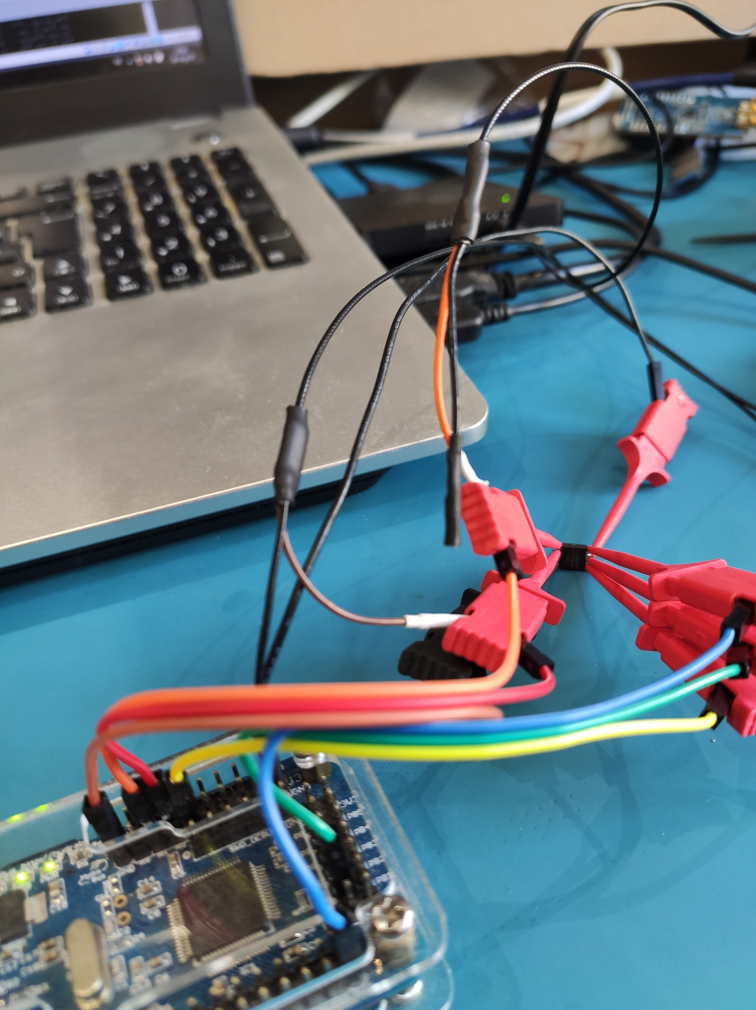

FlashRom with support of HydraBus
This specific version of FlashRom has been modified by Baldanos and use same syntax as for BusPirate but it is enhanced for hydrabus using SPI2 at 21MHz by default, that allow ultra fast read/write of spiflash in few seconds (compared to few minutes on the BusPirate).
See https://github.com/Baldanos/flashrom

It is recommended to use latest hydrabus firmware see https://github.com/hydrabus/hydrafw

Build and usage of flashrom with HydraBus:
Tested with Ubuntu 18.04 LTS
sudo apt install pciutils-dev libusb-dev
git clone https://github.com/Baldanos/flashrom
cd flashrom
make
sudo make install

Test spiflash identification with FlashROM:
sudo ./flashrom -p buspirate_spi:dev=/dev/ttyACM0
flashrom v0.9.9-212-g4c675e7 on Linux 4.15.0-106-generic (x86_64)
flashrom is free software, get the source code at https://flashrom.org

Using clock_gettime for delay loops (clk_id: 1, resolution: 1ns).
Found Winbond flash chip "W25Q16.V" (2048 kB, SPI) on buspirate_spi.
No operations were specified.

Read full SPIFlash with FlashROM and HydraBus:
sudo ./flashrom -p buspirate_spi:dev=/dev/ttyACM0 --read flash.dump -VVV
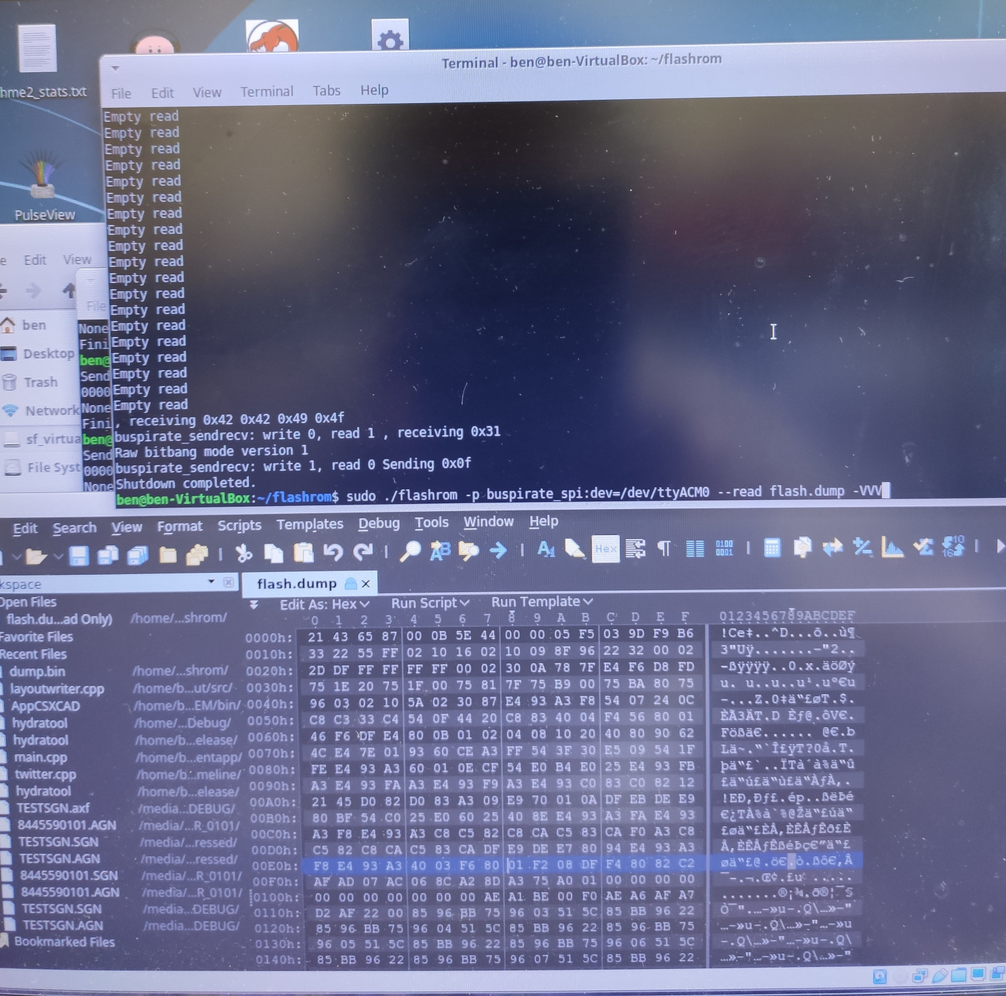

Write full SPIFlash with FlashROM and HydraBus:
sudo ./flashrom -p buspirate_spi:dev=/dev/ttyACM0 --write flash.dump -VVV

